Hive QL is the Query Language used in Hive. It is very similar to SQL. It is used to query data from files and databases and tables. It is used to create, delete and manipulate data in the schema. It does not support row-level update, insert or delete. Hive doesn’t support transactions. Hive uses extensions for better performance in Hadoop.

**Hive Data Definitions:**

Hive Data Definitions is a subset of Hive QL. It is used to define data structures in Hive using commands like create, alter and drop on schema objects such as tables, databases, views and indexes.

create database mydb;

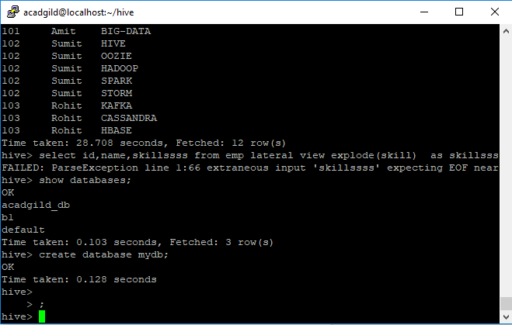

**Hive Data Manipulations:**

DML statements are used to retrieve, store, modify, delete, insert and update data in the database.

Example:

Load Data Local INPATH ‘

